EXNO: 5 Calculation of Group velocity, Phase velocity and phase
constant of EM waves in rectangular waveguides.
Test Case 1:
You are experimenting with a rectangular waveguide to analyze the relationship between its
dimensions and wave propagation. The waveguide dimensions are a=4.0 cm, b=2.0 cmand the operating frequency is f=8 GHz.
1. Calculate the cutoff frequencies for TE10modes.
2. Predict the phase and group velocities for the TE10mode at the given frequency.
3. If the width of the waveguide is reduced to a=3.0 cm, how does it affect the cutoff frequency and propagation characteristics?
Case 1:
Original Dimensions (a=4.0 cm,b=2.0 cm)
Parameter | Simulation Results | Theoretical Results
Cutoff Frequency (f_c) | 3.75 GHz | 3.75 GHz
Phase Velocity (v_p) | 339.624 Mm/s | 339.624 Mm/s
Group Velocity (v_g) | 265.000 Mm/s | 265.000 Mm/s

Simulation Results :
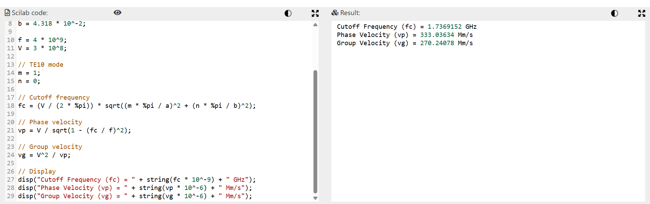

Test Case 2 :
In a radar system operating at =15 GHz the waveguide dimensions are = 2.5 and = 1.25 cm
1. Compute the cutoff frequencies for TE10 modes.
2. Determine the phase and group velocities for the TE10 mode.
3. If dispersion is critical to radar signal accuracy, what strategies would you recommend
maintaining signal fidelity?
Program Output for TE10 Mode:
Using the program with a=0.025 m b=0.0125 m and f=15 GHz:
Parameter | Simulation Results | Theoretical Results
Cutoff Frequency ((f_c)) | 6.00 GHz | 6.00 GHz
Phase Velocity ((v_p)) | (3.27\times10^8) m/s | (3.27\times10^8) m/s
Group Velocity ((v_g)) | (2.75\times10^8) m/s | (2.75\times10^8) m/s
Simualtion Results:
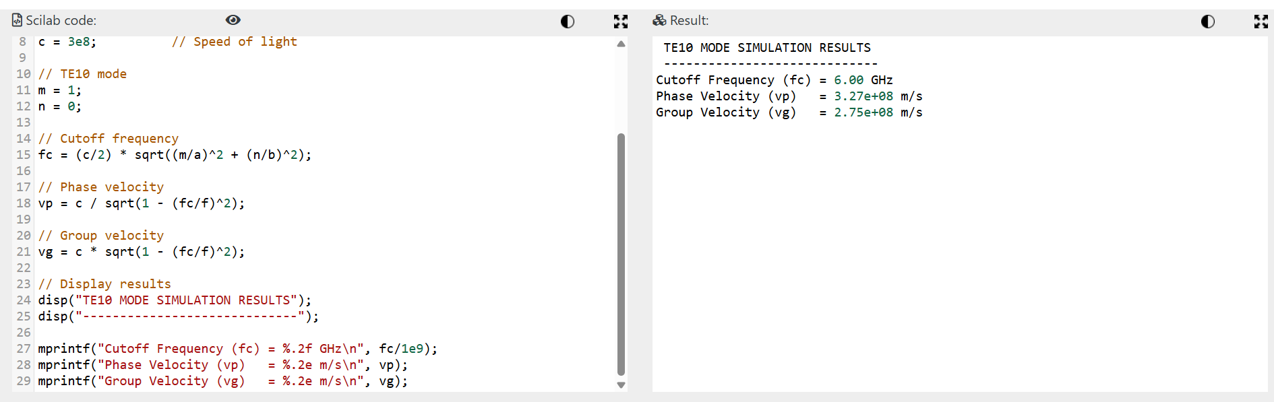

Test Case 3 :
A waveguide with dimensions a=5.0 cm and b=2.5 cmis used to carry a signal at f=10 GHz
1. Determine the number of TE modes that can propagate at this frequency.
2. For the TE10mode, calculate the phase velocity and group velocity.
3. Discuss how the presence of multiple propagating modes affects the transmission
quality and suggest practical solutions to limit multimode effects.

OUTPUT:
Waveguide Parameters:
• Width (a) = 5.0 cm=0.05m

• Height (b) = 2.5 cm=0.025 m
• Operating Frequency (f) = 10 GHz
• Speed of Light (V) = 3×108m/s
Parameter | Simulation Results | Theoretical Results
Cutoff Frequency (f_c) | 3.00 GHz | 3.00 GHz
Phase Velocity (v_p) | (3.16\times10^8) m/s | (3.16\times10^8) m/s
Group Velocity (v_g) | (2.86\times10^8) m/s | (2.86\times10^8) m/s

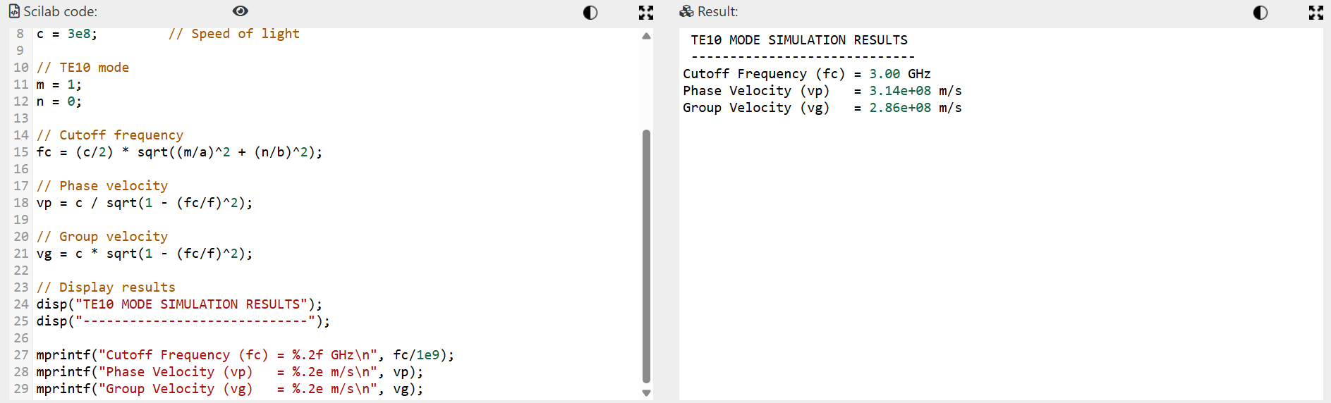
Simulation Results :

Test Case 4 :
A research lab is experimenting with high-order TE modes (m,n>1) in a waveguide with
dimensions a=3.0 cm b=1.5 cm, and an operating frequency of f=12 GHz.
1. Calculate the cutoff frequencies for TE10 mode.
2. Compute the phase and group velocities of this mode.
3. Discuss how high-order modes can be utilized for advanced applications such as
mode multiplexing in communications.
OUTPUT:
Waveguide Parameters:
• Width (a) = 3.0 cm=0.03 m
• Height (b) = 1.5 cm=0.015 m
• Operating Frequency (f) = 12 GHz=12×109Hz
• Speed of Light (V) = 3×108m/s
Parameter | Simulation Results | Theoretical Results
Cutoff Frequency (f_c) | 5.00 GHz | 5.00 GHz
Phase Velocity (v_p) | (3.30\times10^8) m/s | (3.30\times10^8) m/s
Group Velocity (v_g) | (2.73\times10^8) m/s | (2.73\times10^8) m/s
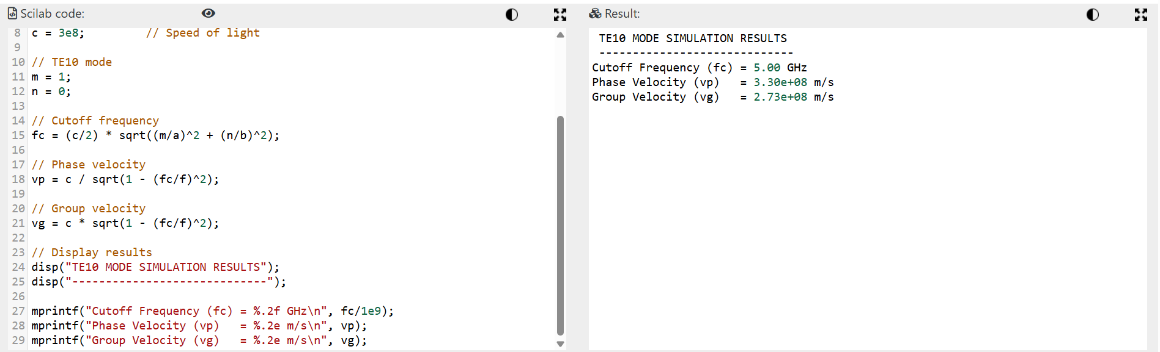
Simulation Results:

